Cascading Organisational Effects from
Inner Leader Transformation
- An Action Research Paper by Into The New -

Abstract
Between September 2021 and March 2024 IntoTheNew have run an Action Research project in the R&D organisation of a large automotive OEM. The research project have held one overarching research question:
Does inner leader transformation lead to quantifiable, measurable positive shifts in the organisational contexts of the leader?
The quantitative measurements presented in this paper gives an answer to that research question: Yes, inner leader transformation lead to substantial, measurable positive organisational shifts. Also, it leads to substantial positive shifts in the private contexts of the leader.
A total 75 leaders, divided in 5 cohorts attended a 9 month inner transformative leader program. The program is built on a synthesis of the research fields of developmental psychology, relational organisational psychology, complex adaptive systems, sustainable change of social systems, and emergent phenomena.
The program use this research to explore, understand and embrace ourselves. To face every facet of ourselves with an open heart. To understand others at depth, using the same research. And to understand the nature of the organisation as a relational, complex, adaptive system.

Organisational measurements were done 3 and 16 months after program completion in the areas of: Collaboration, Outcome, Accountability, Engagement, Decision/Direction Accuracy, Creativity/Problem Solving, and Delivery Precision & Quality. In addition, self-estimates were done within 8 areas of leadership: Self Awareness, Leadership Confidence, Skills in approaching challenges, Ability to hold multiple perspectives, Shape coherence in my team/organisation, To see what is going on in the system, Sense of agency, and Overall life satisfaction.
This report starts with presenting measured, quantifiable, long term effects of the programs.
In the Appendix a wide range of qualitative data is shared: interviews with leaders sharing organisational initiatives stemming from having attended the program as well as quotes from attending leaders.
A selection of the measured results presented in this paper is:
- 100% of attending leaders report an increase of self-awareness and 94% report an increase of overall life satisfaction.
- 98% of attending leaders report an increase of the capability to shape organisational coherence.
- 80% of attending leaders report an increase of output/outcome in “Teams I lead”.
- 80% of attending leaders report an increase of collaboration across areas of competence.

Contents
Table of Contents
The Research Intervention – A 9 Month Inner Transformative Leader Program 3
1.1. Program Process 3
2. Measuring of Long Term Quantitative Effects 4
2.1. Method and Data Collection 4
2.2. Data Analysis 4
2.3. Results in Brief 5
2.4. How to Read the Diagrams 5
3. Results: Presentation of Measured Effects 6
3.1. Measured Effects - Leadership Capabilities: Inner Transformation 6
3.2. Measured Effects - Manifesting Within the Area of Responsibility 7
3.3. Measured Effects - Cascading Outside the Area of Responsibility 8
4. Enabling Factors 9
4.1. Factors enabling these results 9
4.2. About Into The New 9
4.3. Benchmark and State of Art 10
4.4. Contact Information 11
Appendix: Leadership Stories and Attendee Quotes 12
Summaries of Leadership Stories 12
Attendee Quotes and Testimonials from Attendees of 2023 14

The Research Intervention – A 9 Month Inner Transformative Leader Program
The research intervention consisted of a 9 month inner transformative leader program - Holistic, Human Centric Leadership for the Emerging Future of Organisation. An immersive inner development program built on a synthesis of the research fields of developmental psychology, relational organisational psychology, complex adaptive systems, sustainable change of social systems, and emergent phenomena.
The program is a carefully facilitated inner journey using this research to explore, meet and understand ourselves in a multitude of facets, and to embrace every facet with an open heart, non-judgemental. In this, we as individuals can heal and integrate parts of us that we may have avoided meeting, or pushed away due to organisational or societal norms, inner fears or inner stories we live in. According to the underlying research, this can open for expansion of awareness and consciousness leading to leader transformation resulting in measurable organisational effects.
This personal, inner journey deepens the understanding of the psychological and psycho-emotional patterns shared by every human being. This creates a deepened understanding of others, how to meet others where they need to be met in all different situations, and to create organisational systems that serve human growth, interaction, collaboration and collaborative outcomes.
The program is also an explorative journey into organisations as relational, complex systems, where the interconnectedness between self, others and the system is experienced and explored. We also explore the concept of organisational fear, culture and structure, meetings and interactions, and how each of these can support human and organisational growth, or be a hindrance of the same.

Program Process
The program intervention is built on the overarching principle of Intention - Action - Reflection - Learning : learning and transformation grows from reflection on lived experiences.
The program is also built on the principle of deepening our present centred awareness. From a stronger present centred awareness we strengthen and expand capabilities for strategic leadership, emergence as a way to navigate and lead in a complex environment, and continuous, reflective learning. This will open for continuous transformation.

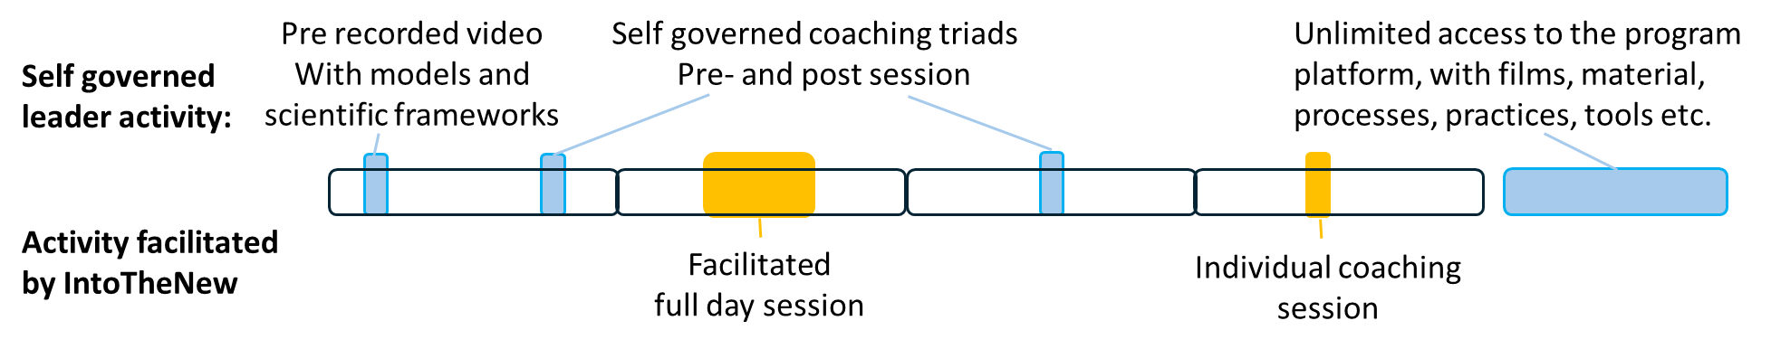

- The program consists of 8 full day sessions, spanning over 9 months. Being in the process for a longer time is essential for inner transformation.
- Models and scientific frameworks are introduced on pre-recorded video for two reasons.
  - to enable the full day sessions to be in explorative experience of these models.
  - to enable for the attendees to revisit any part of the underlying theories as any time.
- Program attendees engage in self-governed coaching triads, supported by carefully crafted practices to explore organisational challenges through the different models and frameworks from the full day sessions. This form a way to integrate the program content into daily leadership, and is a way to form a strong peer support and continuous momentum throughout the program.
- Between each full day session one individual coaching session with a certified developmental coach is offered. This opens for a deepening of the inner transformation, and gives room for personal inquiry into the self.

Measuring of Long Term Quantitative Effects
In this section we will share the method for collecting data to validate long term effects measured with 2022 and 2023 alumni (75 ppl), 16 or 4 months after program completion.

Method and Data Collection
Organisational measurements were done 16 months after program completion of 2021/22 cohorts and 4 months after completion of 2023 cohorts.
Data was collected using a survey covering: Collaboration, Outcome, Accountability, Engagement, Decision/Direction Accuracy, Creativity/Problem Solving, and Delivery Precision & Quality. These 7 aspects have been evaluated within each leader's area of responsibility: the own team and in teams being led, and outside the area of responsibility: within the unit/ department and across functions/areas of expertise (between R&D and e.g. purchase, design, manufacturing).
The survey was designed and distributed by IntoTheNew. Actual data measurements to provide data for responding to the survey was carried out by leaders themselves, using different data sources:
For the areas of Outcome, Decision/Direction Accuracy, Creativity/Problem Solving and Delivery Precision & Accuracy - data sources such as product backlogs, time plans, decision logs, defect tracking systems, and product quality management systems have been available providing hard data.
For the areas of Collaboration, Accountability and Engagement employee survey data has been available, also the lived experience of the shift in these areas among leaders and employees is a source.
Quotes and stories are collected in two ways. Via free text fields in the continuous program evaluation survey, where leaders voluntarily have shared, and via interviews done by IntoTheNew.

Data Analysis
Upon collection of the surveys, data has been extracted, collated and presented in the shape of graphs, shown below. The data is presented in its raw form, with no further analysis or processing, with the intention to present collected data as transparent as possible.

Results in Brief
The measurements prove positive shifts in all areas measured. We also see how the inner transformative shifts within the leaders ripple out to their teams, units and further out in the wider organisation to an extent surpassing our initial expectations.
These leaders’ capabilities of sensing, making sense of and navigating complexity, shaping coherence and shape conditions for their teams to flourish show significant increase.
These shifts shape significant, positive effects within the leaders’ area of responsibility.
These positive effects ripple out through the organisation, also showing measurable positive effects across areas of competence.

How to Read the Diagrams
Below an example diagram is presented.
The colours represent the degree of positive shift measured by the leader.
The number within each colour segment represent the percentage of leaders observing this degree of change.
Examples:
“10%” in the grey coloured segment below means that 10% of the leaders did not note an observable positive shift.
“23%” within the teal coloured segment below means that 23% of the leaders observe a 100% improvement within the measured area.

That is, the above example diagram shall be interpreted as follows:
10% of the respondents note no measurable change (grey segment).
22% of the respondents note a 25% improvement (light green segment)
42% of respondents note a 50% improvement (darker green segment)
23% of respondents note a 100% improvement (soft teal segment)
3% of respondents note a more than 100% improvement (intense teal segment)

Results: Presentation of Measured Effects

Measured Effects - Leadership Capabilities: Inner Transformation
Data collected for the measured shifts within Leadership Capabilities are presented below,

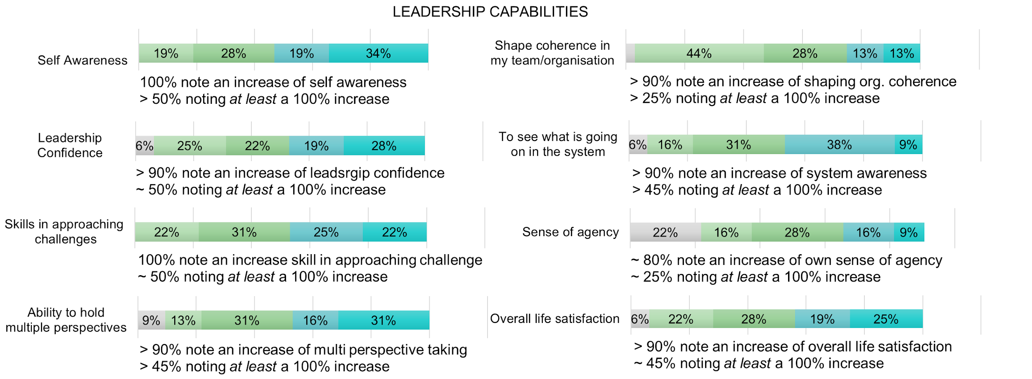

These are remarkable individual effects, hard to find an equivalent to in any other training we know of. They speak for themselves.

Also, an attendee evaluation of the program was done after completion of the full program. The average attendee rating of the three main questions evaluated is presented below.
- How valuable has this program been for you, personally? 9,7 (of 10)
- How valuable has this program been for you, as a leader? 9,7 (of 10)
- NPS (Net Promoter Score, scoring from -100 to +100: 87
(above 30 is usually deemed as good, above 60 as extraordinary)

"I have attended over 30 courses over my 20+ years in my work life. Many of them were leadership courses. This program is without any competition the best I have ever done! And everyone who attended knows why!
It goes deep into human nature and being human together. The implications of that for leadership and organisation... Invaluable! Both privately and as a leader!"
- Aboozar Zarini, Graduate of 2023

Measured Effects - Manifesting Within the Area of Responsibility
Data collected for the measured shifts within the leaders’ area of responsibility: “In My Leadership Team” and “In Teams I Lead” is presented below.

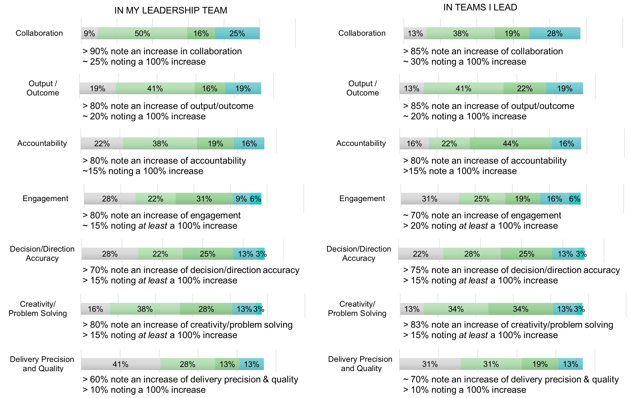

A few aspects worth noticing:
- The effects are sustained over time. Measurements are done 4 months and 16 months after program completion.
- All areas show substantial improvement. 60-90% of the leaders note measurable positive effects in all areas.
- The rate of 100% improvement and above (the teal colours) is notably high for all areas. Measures of doubled outcomes in 20% of the teams being led, and doubled delivery precision in 15% of the teams being led is remarkable, and a strong indicator for the correlation between human centric leadership and delivery.

“I see now in retrospect, that this program have transformed me from inside out. That transformation has really changed my leadership. An effect I see from that is my teams working as one organism now. Almost having tripled their output.”
Henrik, Attendee 2023

Measured Effects - Cascading Outside the Area of Responsibility
Data collected for the measured shifts outside the leaders’ area of responsibility: “Within My Unit/Department” and “Across Areas of Competence” (e.g. between R&D and Design, Manufacturing, Purchase etc.).

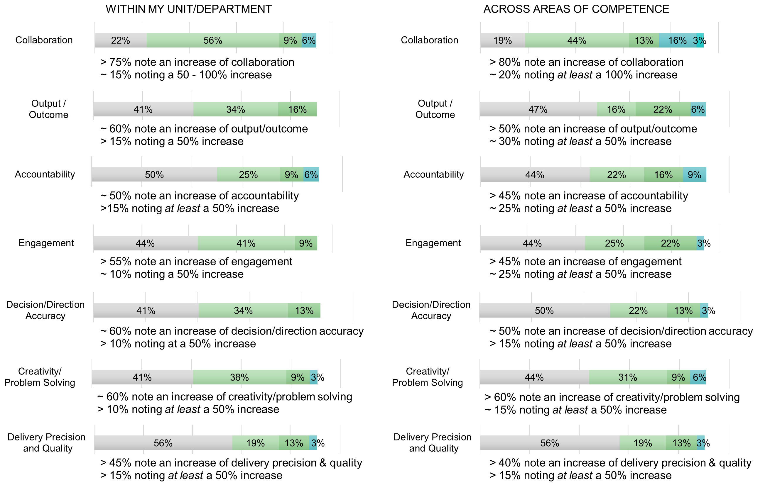

A few aspects worth noticing:
- The effects are sustained over time. Measurements are done 4 months and 16 months after program completion.
- When it comes to the area outside the leader’s responsibility, more than 50% of leaders see measurable positive shifts in most aspects. The effects of the leader program do reach the wider organisation, both within and outside R&D.
- Improved collaboration is the ability that stands out as affecting all areas of the organisation with effects seen by almost all leaders at all levels. It is also noteworthy that 90% note an improvement in collaboration Across Areas of Competence and 20% of the leaders experience at least a 100% increase.

“It is hard to put words on it, but I have gained a much deeper sense of how to lead organisational transformation. And a much deeper sense of the human nature, and the implications on organisation and collaboration. And that shows in our organisational trust and accountability.”
- Daniel Hall, Attendee 2023

Enabling Factors

Factors enabling these results
There are some central keys, with deep origins in the human nature, that enable the inner transformation of leaders, leading to the organisational effects observed in this program. These are presented below:
- The most important factor is to consciously create a psychologically safe space. A safely held space seems to be a very important basis for transformative human development, because inner growth is a vulnerable process. Some keys are:
  - A holding structure, where all the practical things are made easy.
  - We as facilitators participate fully in everything we do. We fully engage in every exploration, every dialogue, every practice and every inner reflection and meditation. We do not lead the group though this journey. We walk every step of the way alongside them.
  - We hold a deep respect for everyone also having a life outside the program. For example, we never blame, or even comment if someone is late, needs to leave early, etc. People are human, and we want to salute that.
- Another, absolutely central key, that differentiates our approach from most other approaches, is to hold the intention to fully embrace everything we see in ourselves, in love and acceptance. Nothing is seen as wrong, broken or imperfect. Nothing needs to be improved, fixed or developed. This enables all our inner figures to feel safe. In that the individual leader gains access to their full inherent power, richness of perspective and ability to sense and make sense of the inner and outer realities.
- We see that our broad foundation of integrated, complimentary scientific frameworks and models serve as a safe way to explore and meet oneself, others and the system. Solid science, which is not seen as 'the truth', but offers validated ways to explore deeper into the self, and the self in interaction with others and the system.
- Truly exploring the scientific fields together: developmental psychology, relational organisational psychology, the natural process of human and organisational growth through complexity and emergence is a key.
- Liberating structures is a key to reach deeper. An example is the way we design exercises and dialogue formats, which enable us to reach deep in a short time. In doing so we can meet and explore on a much deeper level than normally, and open for a deeper transformation.
- Keeping the inner process alive is key. The combination of preparatory video material, full-day sessions, coaching triad exercises between sessions, applying the frameworks to daily leadership challenges and individual coaching provides a continuous flow keeping the inner process alive.
- The peer support formed in the coaching triads has also shown to be vital.
- And finally, the 9-month program duration enables transformation, from the inside out, where it is no longer possible to fall back into "the way we've always done it."

About Into The New
IntoTheNew work for the evolution of human consciousness, to enable for individuals, organisations, and the global system to evolve sustainably.
IntoTheNew guide transformative inner journeys through a synthesis of the research fields of developmental psychology, relational organisational psychology, complex systems, sustainable change of social systems, and emergent phenomena. Inner journeys resulting in the outer effects presented in this paper.
The approach have been developed and refined in collaboration with globally leading researchers over the course of many years, and resulted in validated programs that goes deep into the nature of being human, operating together in relational, complex systems, opening for inner transformation and widening and deepening of human awareness. This lead to personal- and leadership development programs at absolute global forefront.
IntoTheNew leader programs are validated to create leader transformation, enabling a leadership able to face and address the challenges of today. A leadership validated to release human and organisational power and outcomes in an increasingly complex world.
IntoTheNew leader programs are designed with three insights in mind:
- Our world gets increasingly complex by the minute… For an organisation to thrive, sustainably, in this complexity we need new approaches to leadership. We need leadership that holds the capacity to unlock the inherent power of individuals in the organisation. Leadership that can navigate complexity and changing circumstances. Leadership that can shape a safe environment in which people can grow, meet and collaborate to create truly astonishing results.
- Every human system is relational by nature. This is why psychological safety is a key for team and organisational outcomes. When we start to engage with our organisational systems as relational systems, we will together access and make sense of far more of the “data” surrounding us at all times. Enabling more timely action, better tailored responses to challenge, and higher and more quality outcomes.
- This leadership can be grown when we as leaders widen and deepen our awareness. When we truly add and shift the perspectives through which we view the world. When we evolve our understanding of ourselves, others and the system we operate in. It is shown that this leadership shift is very hard to accomplish in a training focused on learning and applying tools and models. Which is why our training is crafted to facilitate the inner transformation needed.

In collaboration with international researchers and practitioners, we also do action research within our field, to move the field forward globally. The result section of this report is one of our action research papers.
We also assist these researchers in crafting and facilitating their certifying global programs.

To enable spreading our insights and approaches, all material produced is licensed under Creative Commons Attributions-Share Alike 4.0 licence. Because we believe that IP that serves the world belongs to the world. These materials are freely shared on the website in the form of video modules, whitepapers, articles, interviews with leaders, a podcast, and videos on our homepage and on YouTube.

Benchmark and State of Art
IntoTheNew is leading edge globally when it comes to transformative leader development, and human centric, sustainable systems change.
There are a few actors doing similar work as IntoTheNew on the global arena. Most are found in the research- and academic world in the United States. Peter Senge at MIT. Otto Scharmer and the Presencing Institute at MIT, Robert Kegan and Lisa Lahey at Harvard are a few examples.

Contact Information
If you are curious of learning more, please get in contact. You reach us on our webpage: www.intothenew.online
Here we also share what we do, freely, licenced under Creative Commons. Because we believe that IP that serves the world shall belong to the world.

With Love
Karin and Niklas

Appendix: Leadership Stories and Attendee Quotes

Summaries of Leadership Stories
We have interviewed attending leaders, to get stories and measures of how the program have shifted their leadership and view on organisation. Brief introductions to these interviews are presented below. Articles on all cases are either available at intothenew.online/resources or in the making.
Shifting the leadership team to lead as one
Martin realized that most of the management team was too stressed, not really present at their meetings, even though they handled really important matters. He also noted the lack of a shared view of the current state and the way forward.
Making a choice at one of these meetings, he set a clear intention for himself: to make this meeting an important, unifying meeting. Consciously shifting his presence, energy and attention, he shaped the meeting into what was needed. Opening to explore ”What is really important to us, here?”. Making sure that the diverse views of the team were heard and unified, the outcome of the meeting was one of alignment. After this single meeting, the experience was the leadership team having come closer to each other. Starting to act in more alignment. After this meeting, dialogues continued to open.
Addressing a deep organisational challenge from co-awareness
Jimmy’s organisation was in a huge challenge, fighting with internal communication problems and lack of flow, hampering both social aspects and technical outcomes. From the program he gained insight in leading complexity and learnt methods to do so!
When the corrective action was presented to the organisation feedback was received that people felt heard, and the management team had listened and understood their daily challenges. Within 2 months the change they initiated results in better communication and collaboration between different parts of their organisation, and a clearly improved flow in development and delivery.
Now, 6 months later, this change have lived and grew, even if Jimmy has been on parental leave. The initiative paved the way to get through the organisational transformation in a better way, and to have a chance to deliver what is needed. Crucial knowledge at important times.
Tripling team outcomes from shifting to post heroic leadership
Henrik has noted an internal shift as the insights of the program have integrated. In this he also observes how he gradually shifts his leadership of his teams. He observes how the team has started to work as one organism, with dramatically increased team safety, co-ownership, accountability, collaboration and dialogue. After summer, he made a reference measurement of team outcomes, noting that the team outcomes have almost tripled compared to before summer.
Shaping the post heroic organisation
Hannes has for the past years consciously shaped a post heroic organisation. In a very systematic approach he, and his leadership team, have shaped structure and culture to enable release of the full power of the organisation, to enable the big technical leap needed, while being aware of taken risk. Some main insights:
- Centre around the WHY of the organisation.
- Continually adjust using well designed organisational feedback loops on all levels.
- Create both culture and structure to keep all inner (psychological) figures safe.
- Enable connection, and presence. Set the human element at centre.
- Enable teams to be empowered.
- Every leader need to walk the talk, being conscious of every step.
Co-sensing to find the keys of a new strategy
A major organisational and technical challenge was explored though the lenses of the program. The awareness around existing paradoxes, open ended questions and organisational tensions born in this exploration gave Jimmy insight to set a new strategy together with his management team. Now going forward with three new main focus points.
A big step forward in a very challenging situation.
How human to human connection fosters accountability
"This program has entirely shifted how I have been capable of leading through these times of re-organisation and restructuring. Also, how I show up and relate privately. I have really internalized the program, and I use many of the tools and practices both professionally and privately. And it really adds colour to life.
We need to re-establish accountability in our organisation. And I clearly see how we must start with human connection. It is crucial to build trust, and to create accountability. I see so clearly that we cannot connect in any other layer if we have not connected human to human. Actually, it is quite refreshing that being human together comes in the first room, unlocking for us to create results together.
And when we start from the right place, results and accountability follow. Crystal clear!”
Leading organisational Transformation
Daniel testifies how the program has significantly helped him lead his organisation through turbulent times of re-organisation, while maintaining engagement. “It is hard to put words on it, but I have gained a much deeper sense of how to lead organisational transformation. And a much deeper sense of the human nature, and the implications on organisation and collaboration. And that shows in our organisational trust and accountability.”
Solving collaboration challenges between organisational units
Magnus and his colleague has completely shifted their approach to the previously challenging collaboration between units. By deepening the human to human connection and building relations very early on in the projects, a space is opened up where the vision and goal can be discussed, challenged and pursued together. During every day work Magnus and his colleague continuously monitor the connection and energy between people, and immediately attend to the issues that has to be solved, the organisational outcomes in this collaboration has dramatically improved.
Solving technical SW performance issues in radically new ways
Being challenged with hard technical improvements needed, Sima took new measures to achieve this. Instead of the usual “let’s all focus on fixing our bugs, and trying to optimize our code” she invited and orchestrated broad collaboration and cross team and department dialogue. A hackathon was one of the physical events taking place, but improvement of the relational and collaborative aspects were the secret resulting in a product improvement 3 times the performance aimed for (previously not reached for months, despite hard work).
Creating dialogue and mutuality between organisational units
Sajed faced organisational and collaborative challenges between departments. Departments suffered from not seeming to understand the other parties’ perspectives, and not seeming to find the time, nor the motivation for doing so. Resulting in conflicts and double work. He brought his challenge to the “Organisational Evolution Program”, bringing perspectives, paradoxes and questions back to his leadership team, enabling them to starts forming a base for activation together, to bring the departments closer together, striving for the same goal.

Attendee Quotes and Testimonials from Attendees of 2023
These quotes come from the program evaluation survey, written in voluntary free text fields. Even if attendees in many cases have shared their names, we do not present names with the quotes since the program survey is anonymous.
“ If it wasn’t for the leader program, I
would have been burnt out by now!
Instead, with the awareness, insights and tools I have gotten, I can lead my organisation through this crisis in new ways.
”
“ This course is not tied to a specific way of
working. It's a necessity for line managers to enable and maximize the power and effectiveness of our organisation!
”

“ I love the richness and complexity of the
models and research. We NEED to bring complexity awareness into how we lead, at all times! And here I have gotten both knowledge, confidence and tools to do that.
And to see that every human being has gifts to offer. We miss this a bit. To make everyone contribute where they are their best!
I am a different man today. And a vastly different leader, for the better. And I get that feedback from my colleagues. I wouldn’t have been be able to lead to achieve what we have done without this program. Thank you!
”
“ I now understand and see the fear
connected to our inner psychological figures. How we can avoid triggering fear in the organisation, and in that avoid to limit and hold people back. And I see greater outcomes in my organisation as we do this.
”

“ After Day 1 I realized that this program will
have huge positive impact for me as a person, Now I also clearly see how the collaboration in my closest groups have improved significantly, we approach challenges differently, we think differently in how to create new things, seeing new ways forward. I also see the same positive benefits with other teams I work with.
”

“ I have become a better version of myself.
This program has been extremely valuable for me in helping my organisation through these intense transformations.
”

“ Without competition the BEST program i
have ever attended (and I have attended many!!) It has made me a happier, nicer and more powerful version of myself. Leading my organisation with more clarity.
”

“ I now see how much we are all bound by
our own assumptions, and how much sharing situations with others can help understanding yourself and the challenge we face together. And help us all to grow.
”

“ I love the depth of the program! The
science you build on really don’t paint a picture in black or white. It shows the complexity of humans, of organisation and collaboration. And you do it SO well!!
I have really lifted my capability as a leader. And gotten the tools to view myself in that role from the outside. Now I really see the system clearer, with more creativity and freedom, and try to do the best for the larger system, as well as for the individual.
”
“ I have 5 BIG take aways from the program
- even if we work with completely different things, we have really helped each other.
- I have very easily been stuck in my Achiever. Being aware of that now makes me widen the perspective.
- The value of co-awareness. Holding a question, both individually and collectively. We have done that a lot, and it makes huge difference!
- And I see things much more clearly now. The system, connections, flow. I can really visualize the system and see what to do. I kind of knew about this before, but now I can really see! Clearly! Zoom in and out in and between different perspectives. So much more aware. That is very powerful as a leader!
- And the last one may seem small: that you're only responsible for yourself in a room. You're not responsible for anyone else. And that is actually really huge. Liberating from both me and others to grow.
BIG BIG thank you! This has been invaluable!
”

“ What stands out the most for me is my own
inner security. I am less in a hurry now- Much calmer. Thoughtful, with a wider range of perspectives, and ability to zoom in and out of organisational challenges. Also, I have gotten feedback from my organisation: I dare show vulnerability and I dare to show that I do not know.
That calm and vulnerability is appreciated in my organisation, unlocking power and accountability.
Also, now when I see what is needed in the organisation, I look beyond my own gain. Looking at the larger system. What will be best for the whole. The greater inner security creates a sense of self safety. And I have been given tools to face my inner critical voices and fears. Just imagine if everyone could act from what is best for the whole…
”

“ I see now in retrospect, that this program have transformed me from inside out. That transformation has really changed my leadership. An effect I see from that is my teams working as one organism now. Almost having tripled their output.
”

“ I have gotten a toolbox that I don’t need to
carry in a suitcase, but that I carry inside. Deeply integrated understanding of how human beings and collaboration works. Immensely valuable in my daily life as a senior technical expert, leading our product into the future.
”
“ This course …. No, I cannot call it a course.
It is a life changing journey, affecting every part of my life for the better. From my leadership to all my private relations and my appetite on life.
This is the best I have ever done! Thank you
”

